# J.S.M College, Alibag

**Synopsis**

**Project on**

**Online Mobile Recharge**

Submitted By

Name of the Student: - Heena D.Jain

Roll No: - 4328

Class: - T.Y B.Sc (I.T)

**Project Guide H.O.D Principal**

(Name of Guide) (Name of H.O.D) (Name of Principal)

**INDEX**

1. INTRODUCTION
   1. Background……………………………………..3
   2. Objectives…………………………………….....3
   3. Purpose and Scope
      1. Purpose……………………………………..3
      2. Scope............................................................4
2. SURVEY OF TECHNOLOGIES................................5
3. REQUIREMENTS AND ANALYSIS

* Planning and Scheduling..................................6
* Problem Definition...........................................7
* Software and Hardware Requirements.............8
* Preliminary Product Description......................9
* Conceptual Models...........................................11

1. REFERENCES..............................................................12
2. Introduction

1.1Background:

In the current system the user who want to recharge their mobile have to go to any shop where recharge is available. They have to go the shop and ask for the specific recharge. The shopkeeper keeps the record of the number in any book.

1.2 Objective:

This project is my effort for Online Mobile Recharge of mobile. This project useful for online recharging of mobile. This System provides recharge of many mobile companies as well as all kind of recharge are possible. This System will provide facility for customer to recharge mobile at anytime from anywhere. This System keeps the history of the past recharges. The user have to register himself.

1.3 Purpose

The purpose of the web application is the automation of mobile recharge. It provides facilities to

Admin:

* To add Tariff plans.
* To update, create and delete the tariff plans.

User:

* To enter and modify personal detail.
* To register himself.
* Can recharge at anytime.

1.4 Scope

This website would help the customers to recharge their phones from anywhere and anytime online.

1. Survey of Technologies

Currently many software are available like ASP.Net, Oracle, SQL SERVER etc. so I have selected ASP as Frontend and SQL Server for Backend and crystal reports for developing different types of reports . Asp.Net, provide us graphical tools to create interface. Query Analyst is a graphical tool that allows creating quires and other SQL scripts and executing them against SQL server database. Quickly create commonly used database objects. Execute stored procedures. Debug query performance problems. Locate database or view and work with objects. Quickly insert update and delete rows in table

1. Requirement and Analysis

3.1 Planning and Scheduling:

The basic plan is to design such a website which would help

the customer order computer accessories at one click as per their requirement.We have scheduled to design this system in about 2 months which will include entire coding of the website.

3.2 Problem Definition:

* Takes lot of time
* In current system maintaining security is very difficult.
* There are calculation errors.
* In today’s world most of the people don’t have time to go to retail shops and do the recharge.
* Every time your talk time runs out, you have to rush to the vendor for buying recharge.
* Sometime while having an important talk/discussion with your friends/family/client, the talk time get over.

3.3 Advantages of Proposed System:

* This is useful for customer to recharge mobile from anywhere and anytime.
* Easy to get information as per requirement.
* More user friendly since .net is a easy language.
* Maintain history of past as well as present recharges.
* Reduces paperwork.
* Very easy to maintain data and information about data.

3.4 Software and Hardware:

Software:

Frontend:ASP.NET with C#

Backend: Oracle 10g

Hardware:

Processor: Pentium3 and above.

Ram: 1GB or higher.

Hard Disk: 20GB

1. Preliminary Product Description

4.1 Feasibility Study:

Feasibility – It is an evaluation of proposal designed to determine the difficulty in carrying out a designated task. Generally a feasibility study precedes technical development and project implementation.In other words, a feasibility study is an evolution or analysis of the potential impact of proposed project. It is the important part of the primary investigation because only feasible project go to development stages.

* Economic Feasibility:-

It deals with economic impact of system on the environment. It is used i.e. benefits in creating the system. We are assuming economically feasible solution. The profit is dependent on the sale of vouchers. Therefore, project is economically feasible.

* Operational Feasibility:-

It is a measure of how well a proposed system solves the problem and takes advantage of the opportunity identified during scope definition and how it satisfies the requirements identified in the requirements analysis phase of the system development.

* Schedule Feasibility:-

It is a measure of how reasonable project timetable is given by our technical expertise, are the project deadline reasonable? Some projects are initiated with specific deadlines. You need to determine whether the deadlines are mandatory or desirable.

A project will fall if it takes too long to be completed before it is useful. Typically this means estimating how long the system will take to develop and if it can be completed in a given time period using some methods like payback period.

* Legal Feasibility:-

Determine whether the proposed system conflicts with legal requirements.

4.2 Modules:

* Registration:

To give new connection to the customer along with customer id.

* Recharge Information:

Allow you to see the recharge product & their information.

* Contact Us:

To allow you contact.

* Forgot Password:

Provide facility when customer forgot password.

* Admin Login:

It allows authenticated admin to enter the system.

* Recharge Report:

Allow admin to view various customer recharge details & also allow admin to delete customer recharge details.

* Login:

It allows authenticated users to enter the system.

* How to Use:

Provide information of how use the system to user.

* Sitemap:

Provide information about all links to user.

Conceptual Model

Use-Case Diagram:



ERD Diagram

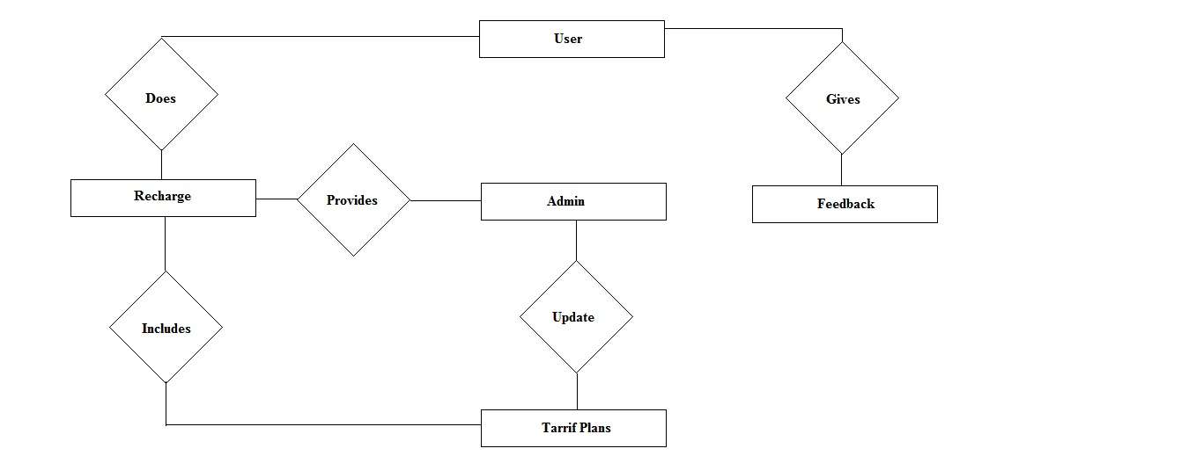

References:

Mentioned references here

Like any website, books, etc.